# Tsuro Analysis

## Overview

Tsuro is a two to eight player game all about people taking paths. The game consists of cards with multiple routes that all intertwine in one way or another, making large paths that can span the board. Players place these cards in hopes of making a path that does not lead to the edge of the board for themselves, however the cards can also interfere with other players to put them at a disadvantage.

**Objective/Goal**

* To be the last player on the board whilst leading other players off it

**Core Experiences**

* Strategising on the best route to go down
* Hindering others’ progression

**Key Mechanics**

* Cards – must connect, and be placed in any orientation
* Hand – having 3 cards at all times
* Card Pile – player draws back to 3 from the limited card pile
* Dragon Card – signifies the first player to draw should the deck deplete & replete
* Game Piece – player can only move along one continuous line

**Gameplay Loops**

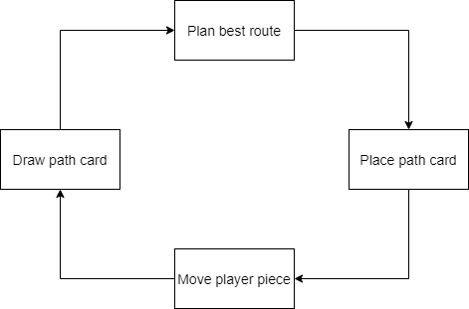

**Critical Analysis**

Tsuro allows a broad audience to play, as it is such a simple game with minimal rules. Players can only put a card in front of their piece, so the challenge comes from the many different directions the cards can go. This makes calculating another player’s move a rewarding challenge. The game is also good for people who don’t have much time as due to its simplicity, it makes for a quick experience.

**Feedback**

The player gets feedback when:

* Moving their piece along the created path
* Drawing cards
* Another player moves on the board

**Summary**

* Cognitive (makes the player think)
  + Planning a route through the many paths – thinking ahead a few moves
  + The board combinations with the 3 cards in your hand – utilising most relevant card
  + Other people plotting routes near you – must figure out how to avoid/redirect them
* Social (makes the players interact)
  + The game does not make players be social but most interaction happens when:
    - Winning or losing the game
    - Interfering with other peoples’ strategies
* Emotional (makes the player feel)
  + Frustrated - When all the cards in your hand lead the piece off the board
  + Annoyed - When someone places a card that leads you off the board
  + Satisfaction - Being the last one on the board